Fuel Injection > A/C Clutch | 

Secondary Air Injection | Electric Cooling Fan
A/C Clutch
To improve idle quality and WOT performance, the PCM controls engagement of the A/C clutch on some systems (figure 4-49).
- At idle, the PCM first commands the IAC valve to increase engine idle slightly, then grounds the A/C relay. This minimizes poor idle quality or stalling.
- The PCM will interrupt A/C operation at wide-open throttle, when maximum engine performance is desired.
- When the power steering pressure (PSP) switch signals high power steering pressure at low engine speed (during parking, for instance), the PCM removes the ground from the A/C clutch relay to prevent stalling caused by the compressor load on the engine.
- If engine cooling system overheating is indicated by the coolant temperature sensor, A/C operation is interrupted.
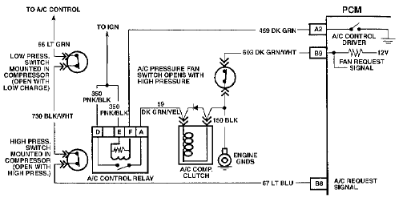

Figure 4-49, A/C Clutch Control Circuit

