Home > Technical Resources > GM > Fuel Injection > A/C System Signal inputs | 

Auto Trans Gear Switches | Power Steering Pressure PSP Switch
A/C System Signal inputs
A/C Request
There is no specific sensor for the Air Conditioning (A/C) request. Instead, the input comes to the PCM from the A/C control head on the instrument panel.
When the A/C system is turned on, the A/C compressor puts a sudden load on the engine. This could lead to driveability problems such as stalling, especially at idle. To prevent this, the A/C switch does not control the A/C compressor directly. Instead, the switch sends an A/C request to the PCM. Depending on the engine control system and engine operating conditions, the PCM does a number of things:
- Delays A/C clutch engagement after A/C is requested
- Adjusts idle rpm to compensate for the extra load
- Disengages the A/C clutch during wide-open throttle operation, when high power steering pressure is present or if engine overheating is indicated

— IMPORTANT —
There are a number of other A/C system switches that must be closed for this to happen. These may include a high pressure switch and/or a low pressure switch. These switches may be in series with the A/C request, or separate inputs to the PCM.
A/C System Sensors
The PCM can have two additional inputs regarding the A/C system (figure 3-51):
- Refrigerant pressure sensor
- Evaporator temperature sensor
The A/C refrigerant pressure sensor responds to changes in system high side pressure. The PCM supplies a 5-volt reference and ground. A signal circuit is monitored by the PCM. On most systems, the PCM uses the pressure sensor signal to identify a resulting pressure increase after the PCM has commanded the A/C compressor clutch to engage. On some other systems, this pressure signal is also used to determine A/C valve position for idle speed control.
The evaporator temperature sensor, also a three-wire sensor, is used by the PCM to cycle the A/C clutch for optimum cooling. Additionally, the PCM can help prevent evaporator freeze-up by disabling the A/C clutch.

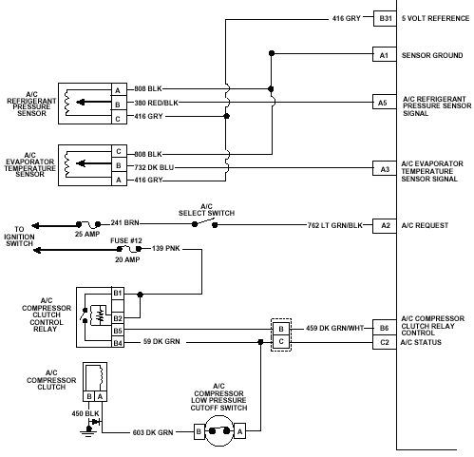
Figure 3-51, A/C System Inputs

Return to the Top
Auto Trans Gear Switches | Power Steering Pressure PSP Switch

©1997 General Motors Corporation. All Rights Reserved. Portions of materials contained herein have been reprinted with permission of General Motors Corporation, Service Technology Group.

